LM35 Temperature Sensor
CP021
Image:
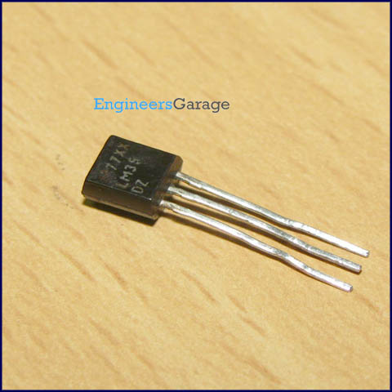
DataSheet:
LM35.PDF
LM35 is a precision IC temperature sensor with its output proportional to the temperature (in ºC). The sensor circuitry is sealed and therefore it is not subjected to oxidation and other processes. With LM35, temperature can be measured more accurately than with a thermistor. It also possess low self heating and does not cause more than 0.1 ºC temperature rise in still air.

The operating temperature range is from -55°C to 150°C. The output voltage varies by 10mV in response to every ºC rise/fall in ambient temperature, i.e., its scale factor is 0.01V/ ºC.
Pin Diagram:
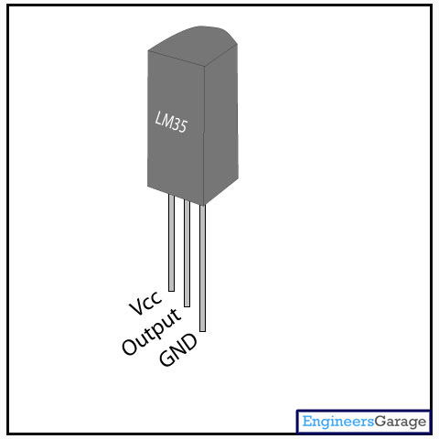
Pin Description:

Pin No | Function | Name
1 | Supply voltage; 5V (+35V to -2V) | Vcc
2 | Output voltage (+6V to -1V) | Output
3 | Ground (0V) | Ground

